25.58: a) 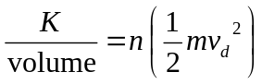
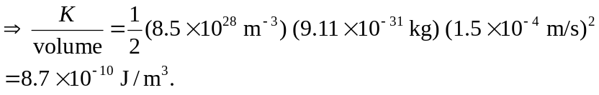
b) 13600 J. And the kinetic energy in 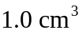 is 